**BSAI-3B**

**Lab_Task_1**

**Syed Tahir Ali 103**

**Dynamic Calculator (DMAS Rule)**

**Overview:**

This is a **Dynamic Calculator** built in Python.  
It evaluates mathematical expressions typed by the user step by step, following the **DMAS rule**:

1. **Division first**
2. **Multiplication next**
3. **Addition after that**
4. **Subtraction last**

Users can type any expression like 6+12*3/4-2 and get the correct result immediately. The calculator keeps running until the user decides to quit by typing **‘q’**.

**How It Works:**

1. **User Input**
   * The calculator asks the user to enter a mathematical expression.
   * Users can exit anytime with **‘q’**.
2. **Breaking the Expression into Numbers and Operators**
   * The expression is read character by character.
   * Digits are combined to form numbers.
   * Operators (+, -, *, /) are stored separately.
   * The final result is a **list of numbers and operators**, ready for step-by-step evaluation.
3. **Applying the DMAS Rule**

**Step 1 – Division:**

* + The calculator first scans the list for /.
  + Whenever it finds division, it checks if the denominator is zero.
  + If zero is found → it stops execution and displays an error message:  
    *“Zero Value Error occurs!! Can't divide by zero.”*
  + Otherwise, the division is performed, and the result replaces the original numbers and operator.

**Step 2 – Multiplication:**

* + After all divisions are handled, the calculator looks for *.
  + Each multiplication is performed and replaced in the list.

**Step 3 – Addition:**

* + Once multiplication is done, the calculator performs addition sequentially.

**Step 4 – Subtraction:**

* + Finally, subtraction is performed to complete the calculation.

1. **Displaying the Result**
   * At the end of all operations, only one number remains in the list.
   * This number is displayed as the final answer to the user.

**Example Run:**

**Expression:** 6+12*3/4-2

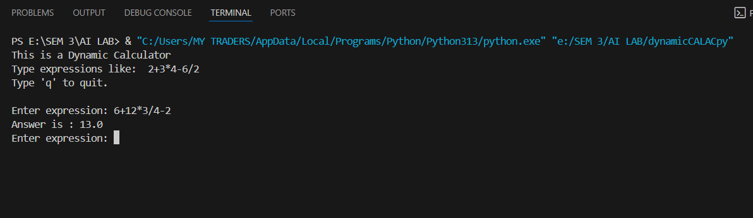

**Processing:**

1. Division first → 3 / 4 = 0.75 → List becomes [6, +, 12, *, 0.75, -, 2]
2. Multiplication → 12 * 0.75 = 9 → List becomes [6, +, 9, -, 2]
3. Addition → 6 + 9 = 15 → List becomes [15, -, 2]
4. Subtraction → 15 - 2 = 13 → List becomes [13]

**Output:** Answer is: 13.0

**Features**

* Handles **DMAS rule** correctly.
* Division by zero is safely detected and reported.
* Can process multiple expressions continuously until the user quits.
* Built from scratch without relying on Python’s built-in evaluation functions.